Assignment 2
Develop a case study analysis the implementation of SDLC phases in a real-world engineering project. Evaluate how requirement gathering, design, implementation, testing, Deployment and maintenance contribute to project outcomes
Case Study: Implementing a Bus Tracking System for a College Campus
For this assignment, I have taken an example of a Bus Tracking System that many colleges use to help students know the live location of their buses. This project uses all phases of the SDLC, and each phase played an important role in completing the system successfully.
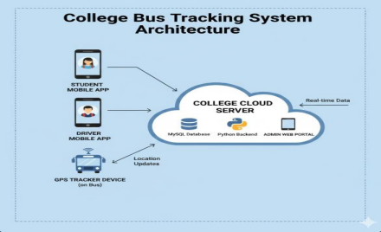

1. Requirement Gathering
The project started with understanding the needs of students, drivers, and the transport department.
The team collected all requirements like:
• Students want to see the bus location in real time.
• Drivers want an easy mobile app to update route or delays.
• Admin wants to manage buses, routes, and timings.
Why this phase was important:
It helped the team understand what exactly needs to be built so that no important feature is missed later.
2. Design Phase
After collecting the requirements, the design team prepared:
• App layout for students and drivers
• Database design for storing bus details
• Flowcharts showing how data will move from GPS device → server → app
Why this phase was important:
A clear design made it easier for developers to follow a proper plan. It reduced confusion and saved development time.
3. Implementation (Coding)
In this phase, developers wrote the actual code for:
• Student mobile app
• Driver mobile app
• Admin web portal
• GPS data processing backend
The technologies used were: Java/Kotlin for the app, Python for backend, and MySQL for the database.
Why this phase was important:
This phase converted ideas and designs into a working real application.
4. Testing Phase
Once coding was done, the testing team checked the system for errors. They tested things like:
• Is the bus location updating correctly?
• Is the app crashing anywhere?
• Can admin add new buses and routes easily?
• Does the driver app send data on time?
Why this phase was important:
Testing helped remove bugs and made the system reliable before releasing it to actual users.
5. Deployment
After successful testing, the system was launched for students and staff. The apps were uploaded to the Play Store, and the backend server was deployed on the college cloud server.
Why this phase was important:
Deployment made the project usable in the real world and ensured that everyone could access it without issues.

6. Maintenance
Even after deployment, the team kept updating the system. Some issues were also fixed later, such as:
• Improving GPS accuracy
• Adding a new feature for estimated arrival time (ETA)
• Fixing bugs reported by users
• Updating the app for new Android versions
Why this phase was important:
Maintenance kept the system running smoothly and increased user satisfaction over time.
Conclusion
This case study shows that every SDLC phase plays a unique and important role:
• Requirement Gathering gives clarity
• Design provides structure
• Implementation builds the actual product
• Testing ensures quality
• Deployment delivers the product to users
• Maintenance keeps the system alive and updated
Because all these phases were followed properly, the Bus Tracking System became successful and useful for the entire campus.

